Az900 Important points

1)

Azure Load Balancer

Fully managed Service

* Internal Load Balancer: From Internal VMs only
* Public load Balancer :- From internet to VMs

2 types

* Basic only 1 VM, Scale Set , Availability Set
* Standard as many Vm as You want
* All VMs must be In same Region and availability set .
* For standard Load Balancers the IPs must also be of kind Standard Type
* Normally Load Balancer works at layer 7 Application Layer
* Azure Load balancer works at layer 4 Transport Layer

2)Azure APPlication gateway

Fully managed service

* URL based routing
* Web based firewall

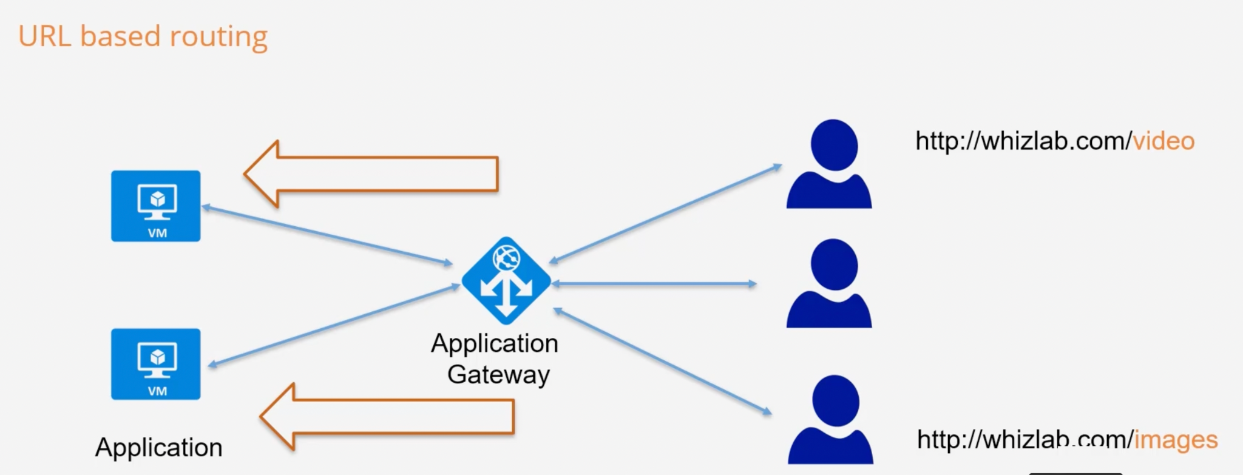

Azure Storage Services

Storage resource ⇒ Must have a unique name.

Create Storage Account —> create Containers—----> then store data

* Blob (Binary Large OBject) :- Unstructured data like images, audio,video,log files etc.
* Table :

Used for strong the Unstructured NoSQl data

This is a ky attribute store

Cost effective option for storage of table like data for applications.

* File :

Allows to retrieval of files via the Server Message Block Protocol

You can mount files shares on Windows, Linux, Max based machines.

Here you don’t need to manage file servers.

* Queue :

Service used for storage and retrieval of messages.

Good when you want to decouple components of a application

A single message in the queue can be upto 64 KB in size (means only text messages).

Can store millions of messages.

While uploading an object in Azure Blob storage , it states select a file, Don’t confuse between that is this BLOB object or File , don’t worry it is BLOB object only .

Access Tiers

* Hot :
  + For frequently used objects
  + Costs more
* Cold :
  + For infrequently used objects
  + Cost less

* Archive :-
  + Ideal for Rarely used data like backup data
  + Can be set only at the object level not at the Container Level
  + Cost Least
  + If objects is marked Archive then objects needs to rehydrated to hot, cool access tier to use it further

File Service :

Add the files and you can connect to it with all 3 types of OS , Linux bases, Windows ,MacOs.

We can set quota as well

Table Service:

Used for NoSQL data .

We can’t add the data directly unlike file service , and need to use Azure storage Explorer.

Azure storage portal is available on Azure portal and is a Stand Alone tool as well .

VPN Gateway :

This is used to connect your on-premise network to an Azure network .

The traffic sent via the Gateway is encrypted.

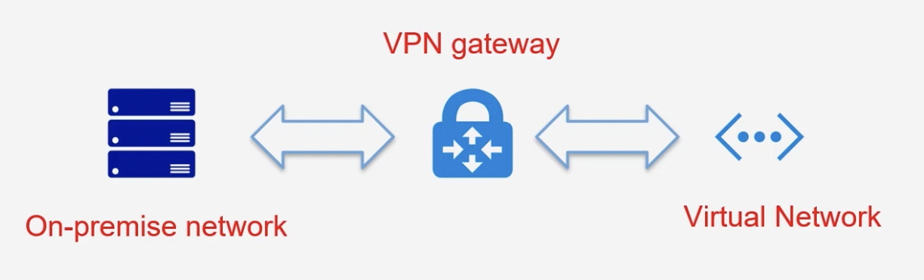

VPN Gateways

(Virtual Private Network Gateway)

Traffic sent via the network is Encrypted .

To establish connectivity with On premise network and Azure Virtual network , in case we are not able to shift whole on premise .

Used where Hybrid

Types

Point to site

Used to connect Workstation to Azure workstation

Site to site

This used to connect on premise networks to Azure networks.

Traffic is encrypted using IPsec protocol

On premise network should have a VPN device with an IP address that is routable over the internet.

Virtual Network Peering

To connect with VMs

1 ways : connect using a public IP address.

2nd way :communicate using Private Ip address

Virtual Network Peering can connect with

Different virtual networks .

Virtual networks which are either located the same Azure region.

Azure ExpressRoute

The service allows you to extend a company’s on premise network to MS cloud using a Private Connection that is provided by a connectivity Provider.

The connection allows you to connect with MS services such as MS azure or office 365 services .

The connection uses layer 3 routing .

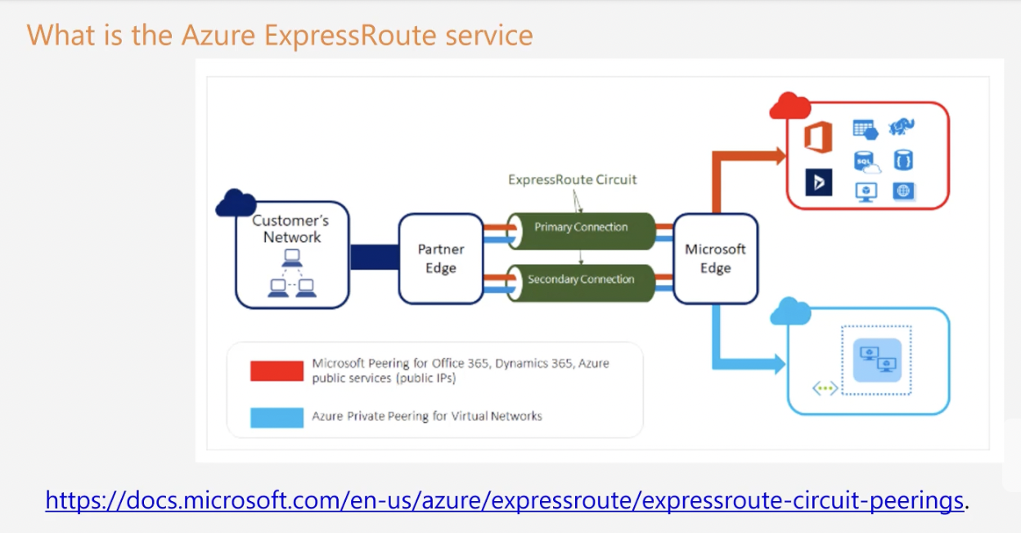

Core Services Part 2

**Azure web Apps**

**Azure web Apps**

2 Resources are allocated while using Web Apps

1. Azure Web app service
2. App service plan

Select a Azure Web App service plan

Devops is possible ⇒ Continuous Deployment

Blue green Authentication is possible

Authenticate using external providers -Azure AD,Facebook,Google.

Key Terms When it comes to Azure Virtual machine

Host Pool

App groups

RemoteApp

FullDesktop

Workstation

End users

**Azure Databricks**

This is Spark based analytics platform that is optimized for Microsoft Azure Cloud .

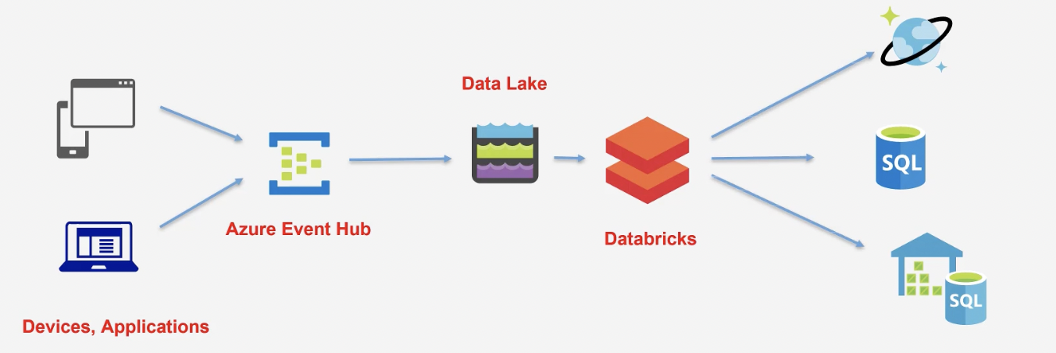

With Azure databricks you can create managed Apache Spark clusters.

You can dynamically automate clusters .You can also create serverless clusters and also share them across teams.

You have easy data exploration with the help of notebooks in R, python, scale and SQL.

You can use interactive dashboards to create dynamic reports .

It has security aspects when it comes to Role based access control and integration with Azure Active Directory .

**Azure HDInsights**

This is a hadoop based component.

This service makes it easier to process large amount of data

This service is based on open source frameworks of Hadoop, Apache spark, Apache Hive, Apache Kafka, Apache Storm, R etc.

You can create Azure HDInsights clusters for batch processing needs.

These clusters are created on-demand. So that we can save on Costs .

**Azure Resource Manager (ARM) Template**

This is a JSON (JavaScript Object Notation) template that contains the resources that you want to create in Azure .

You can then submit the template to Azure Resource Manager .

Azure Resource Manager will then create the resources based on the template definition.

This is good when you have a need to repeatedly need to create the same set of resources - Test environment .

The Different elements of the template

**$schema** - this describes the version of the template language .

**contentVersion**- This the version of the template

**resources**- This is the main section where you define the resources that need to be deployed as part of the template .

**Parameters**

These are the values that can be provided to the template that can be used to customize the deployment of the resources.

**variables** - These are values that can be reused in the template .

**functions**- These are user defined functions that can be used in the template .

outputs- These are values that are returned after the deployment.

Azure Cognitive Service

These are set of services in Azure that helps you to build cognitive intelligence in your applications.

Here you don’t need to have a much knowledge in Artificial Intelligence to use these services .

5 Types:

Vision

Speech

Language

Search

Decision

Computer Vision API:

Api for image processing

It can get information from the images by processing the images.

Or even it can extract text from images.

Speech service :

Provides speech service to an application.

It includes capabilities such as translating speech to text.

Or even converting text to speech .

It can also perform speech translation as well.

Language API:

Allows Text analysis

Understand Text sentiments as well

Decision API:

Here you can check for different aspects i the content .

For example : You can detect any abnormalities in the data collected .

You can also use the Content Moderator to monitor for offensive language .

Search API

Bing News Search : Lsit series of news articles based on a user’s query.

Bing Video Search: This can be used to list a series of video articles based on a user's query.

Bing Search : this can be used to list series if search results based on a users’ query .

Azure DevOps

Azure Boards - Here teams can create and track user stories , backlog items, task, features and bugs that are linked onto a project .

Azure Repos : This is a set of version control tools that helps you manage your code .

Azure Pipelines: This can be used to automatically build and test your code project .

Azure Test Plans : Here you can manage manual testing which includes User acceptance testing, Exploratory testing and Shareholder feedback.

Azure Artifacts - Here you can create and shared Maven, npm and Nuget package feeds from public and private sources with teams of any size.

Azure DevTest labs

This is a service that allows developers or teams to get up and running with the resources such as Azure virtual machines without waiting for approval .

With DevTest Labs, you can create labs based on pre configured Azure Resource Manager templates .

You can also set policies on the number of machines that can be created .

You can set auto Shutdown and auto start schedules on VMs.

‘

Azure Serverless Services

* Here you don’t need to maintain the underlying physical infrastructure.
* You also don’t need to manage the underlying software hosted on the compute infrastructure.

Serverless solutions from Azure

1)Azure Functions: This is serverless compute service.

Here you can deploy your function code onto Azure .

Here you only pay for the amount of time the code runs.

2)Serverless Kubernetes

Kubernetes is used for deploying your container based application

This is a serverless version of kubernetes that is also available.

3)Azure logic apps:

This is used to design workflows in Azure .

Business users can create workflows ad integrations .

Workflows can connect to a variety of Azure services and third party services as well.

Azure Event Grid: This is the event based service in Azure

Here you can work with events generated from Azure services .

Azure Api management

To manage backend APIs .

Azure SQL databases

Apart from Paas , There is a serverless version of Azure SQL database.

Here you only pay for the compute used .

You can pause and resume workloads on the database.

Azure Cosmos DB

Here also they have a serverless Pricing option available .

Azure Functions

Used when you are required to run a code we use Azure functions .

Binding

Input Binding

Output Binding

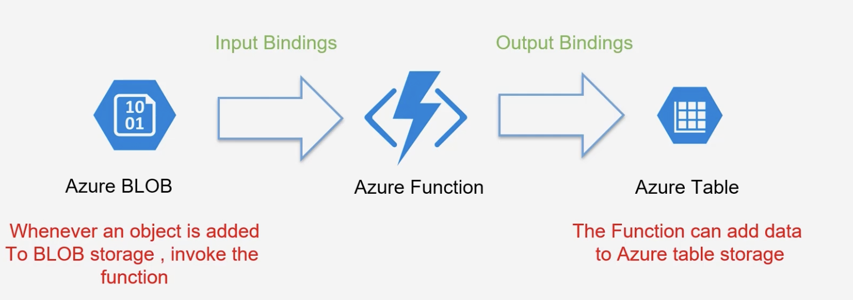

Plans for Azure Serverless

Costing : Consumption plan or App service plan.

Consumption plan- You only get charged for the number of executions, execution time ,Memory used.

Consumption plan — Maximum allowable execution time is 5 minutes.

App service Plan - Have Instances allocated , Have the function running for a longer time , using more memory .

Azure Event Handler

You can take advantage of the Event Grid Service to listen to events emitted by Azure Services .

You can subscribe to various events published by Azure services .

You can then define an Event Handler that can be used too process the event .

You can also define your own custom events .

This services is a highly available service because it is spread across multiple fault domains and availability zones in every region.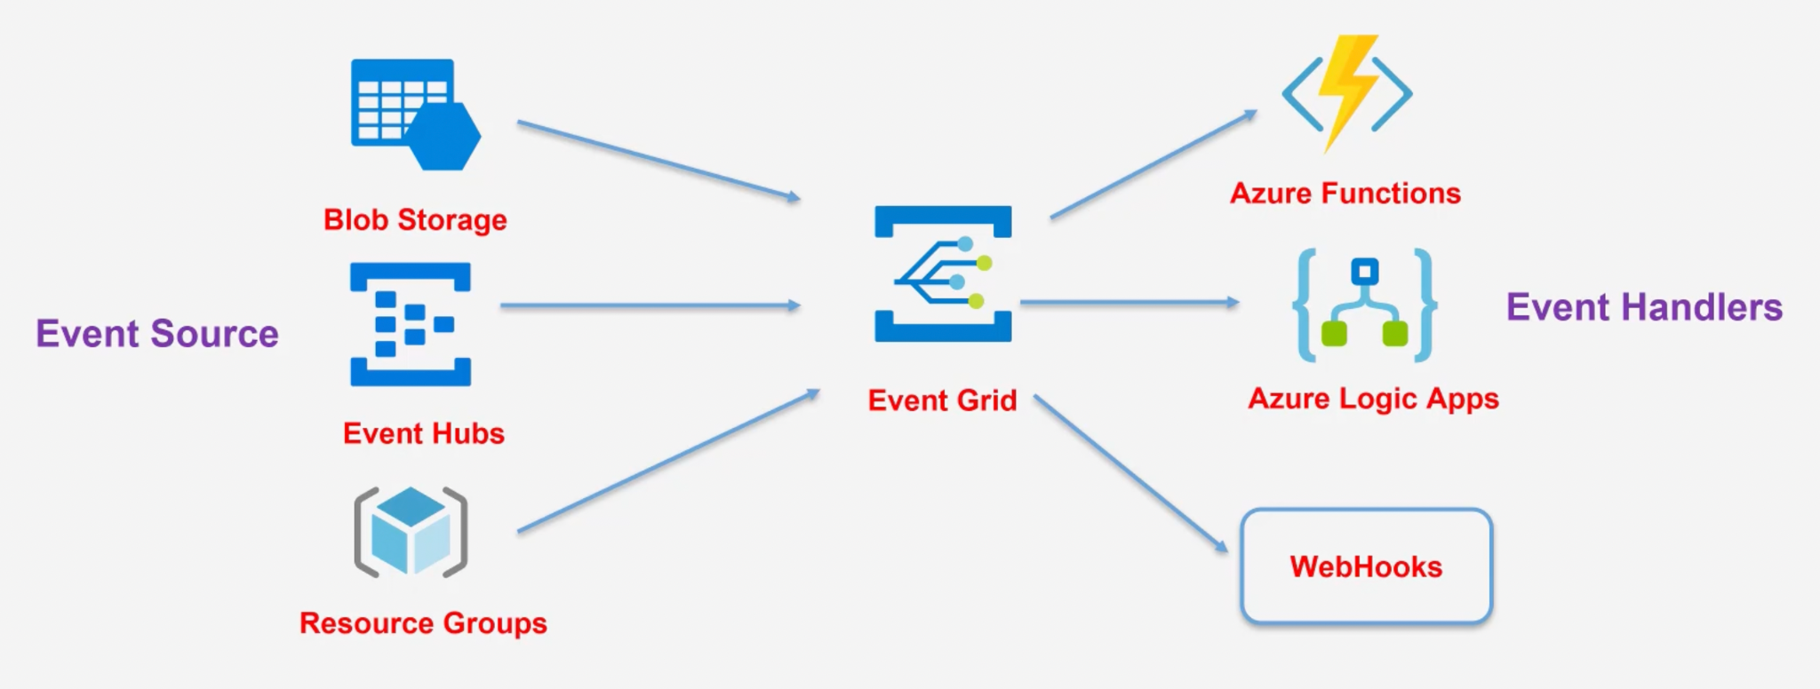

Azure Logic Apps;

Helps us automate and orchestrate tasks .

Helps to build workflows

Various templates already available to build workflows .

Fully managed Azure Service .

You can build workflow and don’t need to worry about the infrastructure to store the workflows.

Workflows can integrate with various Azure Services and third party services as well.

You can build workflows via a visual designer .

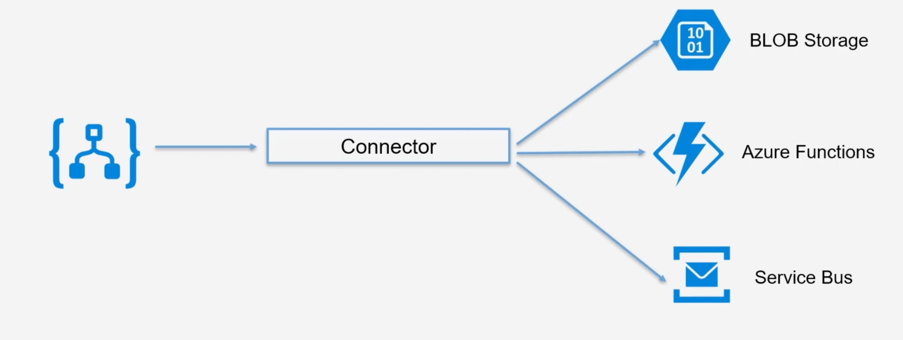

Parts:

Triggers -

Some of the connectors like Azure BLOB storage have the facility to trigger the Azure Logic apps

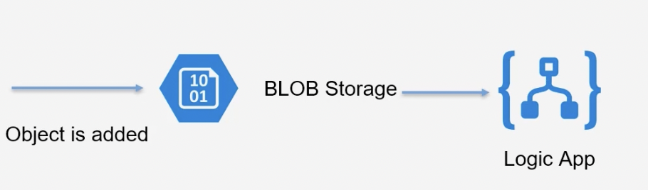

Actions: —

What to do when an event is triggered .

Do you want to send an email to the IT administrator on the event ?

Do you want to call Azure Functions?

Azure Cosmos DB :

Multi model database

Low latency access to data

Instant replication of data across regions.

Scales based on demand.

Fully managed and serverless.

Multi Model DB

We can use table Api to store Table like Data .

SQL api to store sql queries.

Or could even store data based on the Mongo Api .

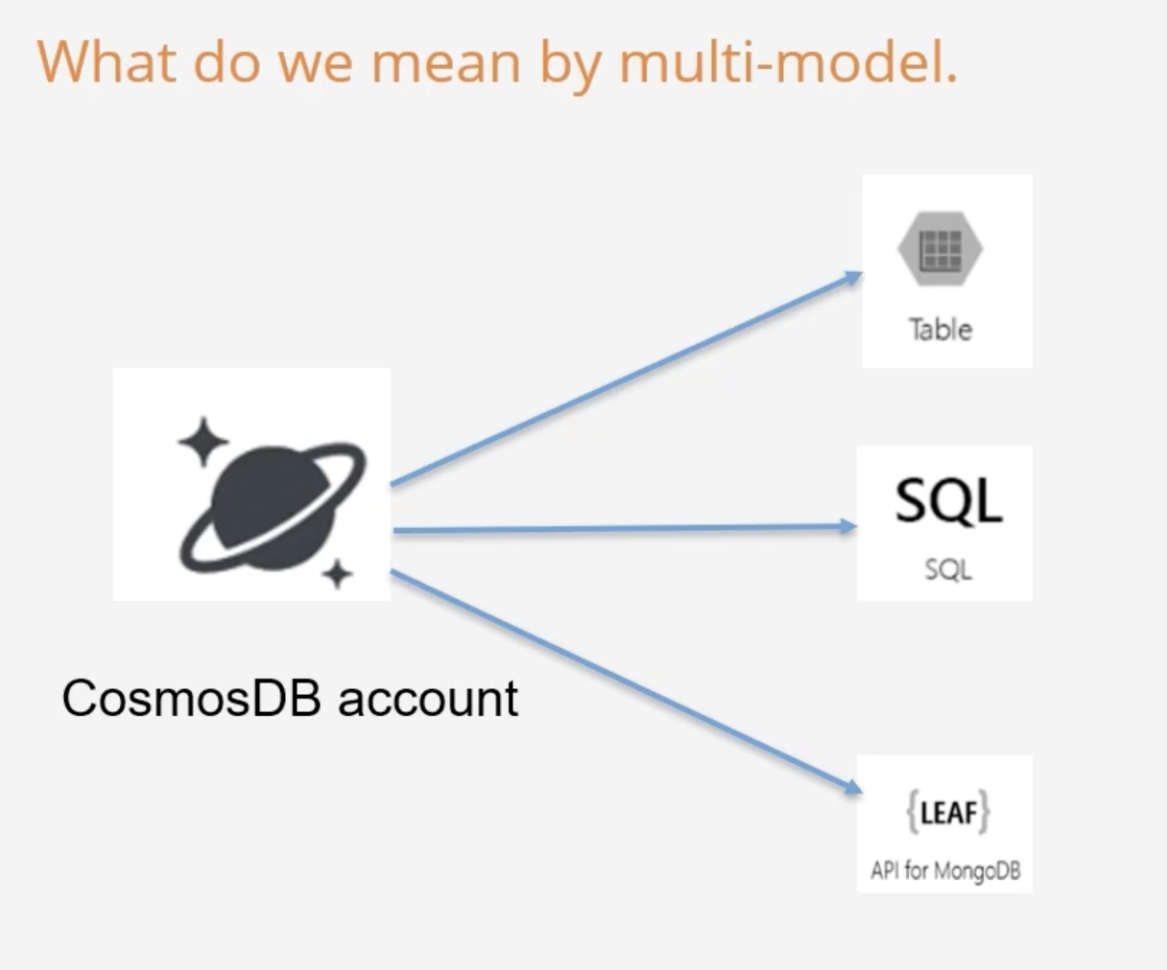

Features of Cosmos DB :

Provides 99.999% availability for reads and writes .

Ability to scale from thousands to hundreds of millions of requests/sec.

Cosmos DB guarantees less than 10 ms latencies for read and indexed writes at the 99th percentile .

Work with Various API’s - SQL , Mongo ,cassanddra , GREMlin and Table.

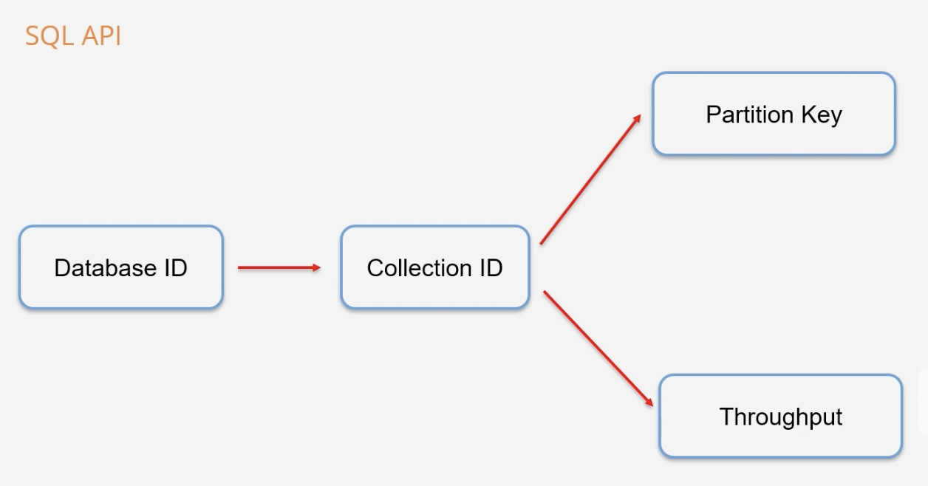

Throughput

This ensures CosmosDB allocates the right resources .

The throughput is a combined measure of CPU,Memory and IOPS.

Helps have an even measure no matters which API you choose

The throughput is measured in Request Units .

The cost to read a 1-KB item is 1 Request unit .

Billing is done on an hourly basis.